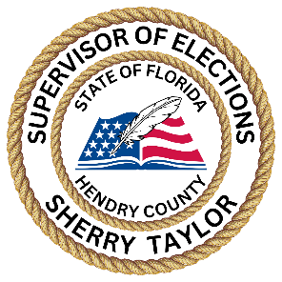
Election Workers are an important component of the elections process. Election Workers are the frontline representation of the Supervisor of Elections office. Often, a voter may never see a SOE staff member, but will see Election Workers at their polling location on Election Day.
Hendry County Election Workers are trained individuals who are active voters, serving their community and local government proudly. Election Workers interact well with the public and work well in stressful situations.
To become a Hendry County Election Worker, you must meet the following requirements:
You must be a registered voter in Hendry County.
You must fill out an Election Worker Application.
You must attend a minimum of 3 hours of training. Hendry County Election Workers are paid volunteers.
Election Worker positions consist of:
- Clerk
The individual in charge of the precinct on Election Day. The Friday before the Election, all Clerks are required to report to SOE Office. They will pick up a canvas bag containing materials and documents for their assigned precinct. When Election Day has ended the bag and specific supplies are to be returned back to the SOE Office.
- Assistant Clerk
The role of the Assistant Clerk is to assist the Clerk in all his/her duties; take over for the Clerk in the event they cannot perform their duties; primarily Assistant Clerk's role is to assist all voters who may need to execute a Provisional Ballot.
- Inspector
Ballot Inspector is the individual appointed to issue ballots to the voter according to their receipt from
the EVID Inspector.
- Equipment Tech
The ET is responsible for setting up the ADA ExpressVote and DS200. ET will be responsible for and trained to open, troubleshoot, and close the equipment on Election Day. They instruct the voter how to insert the ballot into the optical scanner, and assist the visually impaired voter how to insert their ballot into the optical scanner, and assist the visually impaired voter with the execution of an audio ballot. They will make contact with the clerk to set up the precinct.

- EViD Operator
The responsibility of an EViD Operator is to check in voters with EViD unit to determine voter eligibility. Voters provide their identification and it is scanned in the EViD. Eligible voters are presented a pass and directed to the Ballot Inspector. They present that pass and are issued a ballot. Workers also greet voters; assist with directing voters through the process within the precinct.
- Deputy – This Election worker is stationed outside the voting room on Election Day to maintain the order at the polling place. This person sets up voting booths and puts out election office signage at the Elections. A background clearance is conducted by the Hendry County Sheriff’s Office prior to assignment.
*In order to participate, you must be a registered voter in Hendry County. Each worker is required to attend a training class and meet certification requirements in order to work. Training is not paid if you do not work Election Day.

All Workers help with setting up the polling site and assisting voters.

